Exercise 2: E-commerce Platform Search Function

class Product{ int productId;
String productName; String category;

Product(int id, String name, String cat){ productId = id;
productName = name; category = cat;
}
}

public class Ecommerce{
public static void linearSearch(Product[] products, int targetId){ boolean found = false;
for (int i = 0; i < products.length; i++){
if (products[i].productId == targetId){ System.out.println("Product Found using Linear Search:"); System.out.println("ID: " + products[i].productId); System.out.println("Name: " + products[i].productName); System.out.println("Category: " + products[i].category); found = true;
break;
}
}
if (!found){
System.out.println("Product not found using Linear Search.");

}
}

public static void binarySearch(Product[] products, int targetId){ int start = 0;
int end = products.length - 1; boolean found = false;
while (start <= end){
int mid = (start + end) / 2;
if (products[mid].productId == targetId){ System.out.println("Product Found using Binary Search:"); System.out.println("ID: " + products[mid].productId); System.out.println("Name: " + products[mid].productName); System.out.println("Category: " + products[mid].category); found = true;
break;
}else if (products[mid].productId < targetId){ start = mid + 1;
}else{
end = mid - 1;
}
}
if (!found){
System.out.println("Product not found using Binary Search.");
}
}

public static void main(String[] args){ Product[] products = {

new Product(101, "Laptop", "Electronics"), new Product(102, "Shoes", "Footwear"), new Product(103, "Watch", "Accessories"), new Product(104, "Phone", "Electronics"), new Product(105, "Bag", "Accessories")
};

int targetId = 103; linearSearch(products, targetId); binarySearch(products, targetId);
}
}

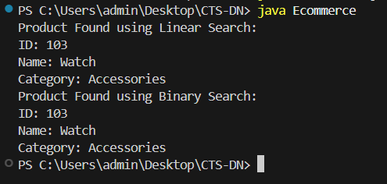

Exercise 7: Financial Forecasting

public class FinancialForecasting{
public static double calculateFutureValue(double currentValue, double rate, int years){ if(years == 0){
return currentValue;

}
return calculateFutureValue(currentValue, rate, years - 1) * (1 + rate);
}

public static void main(String[] args){ double currentValue = 1000.0; double rate = 0.10;
int years = 3;
double futureValue = calculateFutureValue(currentValue, rate, years); System.out.println("Predicted Future Value after " + years + " years: " + futureValue);
}
}

